Project Proposal : Digital Park Guide Training Platform for Sarawak’s National Parks and Nature Reserves

Background / Problem Description
Sarawak's national parks and nature reserves are among the most biodiverse ecosystems in Southeast Asia, and the park guides and rangers who steward these environments play a critical role in shaping both visitor experience and conservation outcomes. SFC recognises that the growing demands of eco-tourism require a more structured, scalable approach to guide and ranger professional development.
Sarawak Forestry Corporation (SFC) currently manages 67 gazetted Totally Protected Areas (TPAs) across Sarawak, comprising 47 national parks, 15 nature reserves, and 5 wildlife sanctuaries. Supporting these protected areas is a workforce of approximately 200–250 active licensed park guides — against a government target of at least 300 — and an estimated several hundred field rangers, including 250 Wildlife Guardian Rangers recruited from army veterans and local communities to assist with enforcement and patrol duties. Despite this considerable operational scale, the training infrastructure supporting these personnel remains predominantly instructor-led and physically centralised, placing significant logistical burdens on those expected to participate. Guides sometimes have to travel to central sites, take long leaves from their job, and not being paid while they are undergoing training, this indeed is a burden that falls particularly hard on guides stationed at remote park locations. The existing constraints have resulted in reduced enrolment figures, incomplete training initiatives, and an overall decrease in the professional readiness of the guiding workforce. Furthermore, the unchanging nature of these programs leads to infrequent updates on the latest developments in conservation science, park regulations, and eco-tourism best practices, resulting in gaps in knowledge that could threaten visitor safety and environmental protection.
The SFC has concluded that guided field excursions necessitate enhanced oversight alongside training efforts. Without a reliable, scalable mechanism to monitor guide conduct and visitor behaviour in real time, enforcement of park regulations remains reactive rather than preventive — leaving protected flora and fauna vulnerable to prohibited activities that may go undetected or undocumented.
This proposal suggests building an integrated Digital Park Guide Training Platform to deal with these connected problems. The platform will provide modular, self-paced training content accessible via both web browser and mobile device allowing guides to improve their skills flexibly without interfering with field operations. Complementing this, an AI monitoring system leveraging device cameras and real-time computer vision with the detection model served from the cloud and cached on-device via the PWA service worker, enabling offline inference without dependency on a persistent server connection, proactively detect abnormal or non-compliant activities during guided tours, trigger automated alerts to park authorities, and securely archive video evidence for accountability and future training reference.
This initiative is to create a smarter, more connected park management system that uses new technology to improve professional standards, make conservation enforcement stronger, and make Sarawak's natural heritage sites world-class eco-tourism destinations.

Scope
This project delivers an integrated Digital Park Guide Training Platform for the Sarawak Forestry Corporation (SFC), addressing two core operational gaps that cannot be resolved through existing off-the-shelf solutions.
The first gap is training accessibility. SFC's current instructor-led model requires guides and rangers to attend centralised sessions, creating barriers of travel, income loss, and scheduling conflict that have suppressed enrolment and left the active guide pool below its target capacity. A digital platform eliminates these barriers by delivering training through a web browser and installable mobile application, allowing field staff to complete certified training modules at their own pace without leaving their assigned park.
The second gap is field oversight. There is currently no systematic mechanism for monitoring guide conduct or detecting conservation violations during guided tours. The platform addresses this through an on-device AI monitoring system that operates independently of internet connectivity — a deliberate design decision given the unreliable network conditions across Sarawak's remote park environments. The platform delivers three functional areas stated below:
Digital Training & Certification Management
A modular e-learning system supporting two certification tracks: Guide Training (focused on biodiversity, habitats, and tour facilitation) and Ranger Training (focused on park management and conservation operations). Each certificate is park-specific and non-transferable across TPAs, in line with SFC's operational structure. The system manages the full certification lifecycle from application submission through HoD review, interview scheduling, payment processing, and badge issuance.
AI-Based Abnormal Activity Monitoring
An AI monitoring system using a pre-trained computer vision model served from the server and cached on-device via the PWA service worker. Once cached, the model runs inference locally against the device camera feed, enabling real-time detection of conservation violations without requiring an active internet connection to detect prohibited activities during guided tours in real time. Evidence is captured, compressed, and stored with full metadata for review and reporting by authorised personnel.
Role-Based User Management
A defined access hierarchy — SFC Management, HoD, Senior Guide/Ranger, and Guide/Ranger — with data access scoped to each role at the database level, ensuring guides see only their own records and seniors see only their assigned groups.

What is explicitly out of scope for this delivery:
- Native iOS or Android application — the mobile experience is delivered via a Progressive Web App (PWA), which provides equivalent accessibility including home screen installation, offline caching, and push notifications without requiring App Store distribution or a separate codebase
- Cloud-based AI inference — while the model file is hosted on the server and downloaded on first PWA load, all inference is executed locally on the device using the service-worker-cached model. No video frames are transmitted to a server for processing, preserving offline functionality. **add feasibility on other edge devices such as rasp pi, Arduino or laptop. Whats is the possibility and performance.
- VR/AR training simulations — identified as optional in the project brief and excluded from the current scope of delivery
- Live payment processing — Stripe integration operates in sandbox mode for demonstration purposes; production payment activation is subject to a separate go-live arrangement
- Production environment deployment — the platform is developed and demonstrated in a staging environment; production infrastructure provisioning is outside the current engagement

Stakeholders

- Dr Lee Su Han
Client Representative & Project Supervisor Dr Lee represents the Sarawak Forestry Corporation's interests in this engagement and serves as the academic supervisor overseeing project delivery. Her interest is in ensuring the platform addresses SFC's operational requirements — standardised training across all TPAs, regulation enforcement through AI monitoring, and a certification pipeline that is manageable by HoD-level administrators. She holds final approval authority over scope decisions and deliverable acceptance.
- HoD / Administrators
Platform Operators Internal SFC staff responsible for day-to-day platform management. Their interest is in tools that allow them to efficiently manage training content, review certification applications, conduct interviews, issue badges, and review AI-flagged evidence without requiring technical expertise.
- Park Guides & Rangers --- can remove ranger
Primary End Users The field workforce who will interact most directly with the platform. Their interest is in a system that is accessible from mobile devices in low-connectivity environments, allows them to complete training without taking extended leave or sacrificing income, and clearly tracks their certification status and renewal requirements.

- Public Users
Prospective Applicants Members of the public who may browse SFC announcements and training programme briefs before deciding to apply as a guide or ranger. Their interaction with the platform is read-only and requires no account creation.
- Development Team
Project Delivery The student team responsible for designing, building, and delivering the platform within the agreed two-sprint timeline. The team's interest is in well-defined requirements, a clearly scoped engagement, and producing a technically sound system that meets the client's objectives.
The following diagram illustrates the role hierarchy within the platform, showing the reporting structure from SFC Management down to field-level guides and rangers.
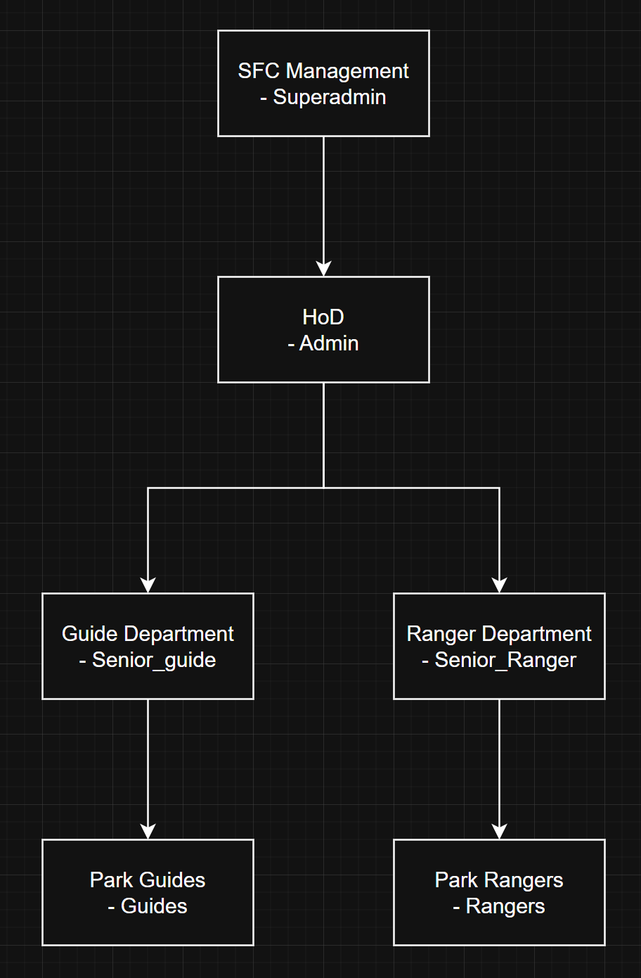
Figure 1 - Platform Role Hierarchy

Simplify, can remove ranger, can treat them as admin

Deliverables and schedule
- Fully Functional Web Application

The core deliverable of this project is a complete Digital Park Guide Training Platform built using Next.js as the fullstack framework. This includes all frontend interfaces and backend API routes, role-based access across all user types (SFC Management, HoD, Senior Guide/Ranger, Guide/Ranger, and Public), and a Progressive Web App (PWA) configuration allowing mobile installation without App Store distribution. The application will be deployed to a staging environment via Vercel.
Acceptance Criteria:
- All six user roles (SFC Management, HoD, Senior Guide, Senior Ranger, Guide, Ranger) can authenticate successfully via both Google OAuth and OTP, and are presented with role-appropriate dashboards with no access to unauthorised routes
- A guide or ranger can complete the full certification lifecycle end-to-end, from training module completion and quiz submission through to badge receipt via email, within a single user session without manual intervention from the development team
- The platform is installable as a PWA on a mobile device and demonstrates offline access to previously loaded training content when network connectivity is disabled
- Role-based data isolation is verified, a guide account cannot retrieve records belonging to another guide, and a senior can only access records belonging to their assigned group, confirmed through both UI testing and direct Supabase RLS policy verification
- The application passes deployment to Vercel staging with all environment variables configured, and all primary user flows are functional on the staging URL without local development dependencies

- AI Monitoring System
An on-device abnormal activity detection module integrated into the platform, utilising a pre-trained computer vision model hosted on the server and cached on-device via the PWA service worker, with live device camera feed as input. This includes the full evidence pipeline, real-time detection, on-device alert, H.264 video compression via FFmpeg.wasm, upload to Supabase Storage, and PostgreSQL metadata logging — as well as offline queuing and background sync for low-connectivity environments.
Acceptance Criteria:
- The pre-trained model is successfully served from the server, downloaded, and cached by the service worker on first PWA initialisation. Following caching, the model must load and begin processing camera frames within 5 seconds of a monitoring session being started, without requiring an active network connection.
- Upon detection, a timestamped evidence clip is captured, compressed to H.264 via FFmpeg.wasm, and uploaded to Supabase Storage with full metadata (guide ID, activity type, confidence score, timestamp) inserted into PostgreSQL — all within 60 seconds of the detection event on a network-connected device
- Offline capability is demonstrated end-to-end: with network disabled after initial PWA load, (a) the model loads from service worker cache, (b) a detection event is triggered via device camera, (c) the evidence clip is queued locally, and (d) upon restoring connectivity, the queued clip syncs automatically to Supabase Storage without manual intervention.
- The on-device alert (sound and visual) fires within 3 seconds of a detection event regardless of network status, confirmed through testing in both online and offline conditions
- All stored evidence clips are accessible to HoD via the admin dashboard, and Senior Guides/Rangers can only view clips associated with their assigned group — verified through role-based access testing
- Database & Backend Infrastructure
All Supabase configurations required to support the platform, including the full PostgreSQL schema with Row Level Security (RLS) policies, Edge Functions, Storage bucket setup and access policies, and forward-only reversible database migration scripts. Seed data covering sample training modules, test user accounts, and sample evidence clips will also be provided to support demonstration and testing.
- Third-Party Integrations
Working integrations with all external service providers used by the platform. Stripe (sandbox payment processing for certification fees), Twilio (SMS notifications), Supabase AUTH (Google OAuth) and Web Push API with VAPID keys (PWA push notifications).
- Technical Documentation
A complete set of technical documents to support understanding, maintenance, and future development of the system, including system architecture overview, all system flow diagrams, API documentation, and a setup and deployment guide covering environment configuration and local development setup.
- Security Assessment
A full application vulnerability assessment conducted in accordance with the Secure Software Development Lifecycle (SSDLC), including the testing plan, tools used, findings report, implemented remediation, and a reassessment report confirming that identified vulnerabilities have been resolved.
- User Manuals
Two separate user manuals written for non-technical audiences — one covering the Guide/Ranger perspective and one covering the HoD/Admin perspective — documenting all key workflows and system interactions.

Initial Release Schedule
Product Backlogs – mention more about stages of AI
No. | Item | Functionality | Dependencies | Business Value  (1 least – 10 most) | Release Schedule  (Sprints)
1 | User Registration & Authentication (OAuth + OTP) | Entry point allowing new users to register account via social login or OTP verification before any platform feature can be accessed. | NA | 10 | Sprint #1
2 | Role-based access control | RBAC across the platform based on assigned role defining accessible features. | 1 | 10 | Sprint #1
3 | Public browsing (announcements, programme brief) | Public-facing view where public can browse SFC announcements and training programmes | NA | 7 | Sprint #1
4 | Qualification application submission module | Allow new user to submit qualifications for HoD Review and schedule interview session for further evaluation | 5 | 9 | Sprint #1
5 | Training module upload & management (HoD) | Allow HoD to CRUD training module & certification standards for each TPAs | 1, 2 | 9 | Sprint #1
6 | Training module view & completion (Guide/Ranger) | Allow Guide/Ranger to browse training module via PWA/Web browser | 5 | 9 | Sprint #1
7 | Quiz system | Quizzes system with result recorded for overall assessment evaluated by HoD for badge issuance | 5 | 8 | Sprint #1
8 | HoD certification review & interview scheduling | HoD reviews /approves/reject submitted application and schedule interview with applicant via email notification | 7 | 9 | Sprint #1
9 | Stripe payment integration (sandbox) | Stripe’s payment gateway sandbox to process certification fees | 7 | 7 | Sprint #1
10 | Badge/certificate issuance & email delivery | HoD issuing park-specific badge, system deliveries via Email | 8, 9 | 9 | Sprint #1
11 | Senior auto-nomination logic | Automatically nominates guides and rangers who have held and renewed their badge over a qualifying period to Senior level | 2, 10 | 6 | Sprint #1
12 | Notification system (Email, SMS, In-app, PWA push) | Notification module are triggered automatically by system events or manually announced through Admin dashboard | 2 | 8 | Sprint #1
13 | AI monitoring — webcam feed + local model | Live webcam feed on edge device and runs locally pre-trained AI model to continuously analyse video frames for abnormal activities during guided tours. | 1 | 10 | Sprint #2
14 | Evidence capture + H.264 compression | System automatically captures abnormal activities and timestamp video clip as evidence, compressing via FFmpeg.wasm (H.264 codec) directly in browser, reducing file size by approximately 95% BEFORE any upload attempt | 13 | 9 | Sprint #2
15 | Supabase Storage upload + PostgreSQL metadata logging | Uploads compressed clip to Supabase storage along inserting metadata to PostgreSQL database | 14 | 9 | Sprint #2
16 | Offline queue + background sync | Edge device without internet connectivity will have evidence clips and metadata queued locally on edge device, once back online, system automatically syncs queue to Supabase in background | 15 | 8 | Sprint #2
17 | On-device alert (sound/visual on detection) | Fires locally, without internet access required, immediate on-device sound and visual alert the moment abnormal activities is detected, notifying staff on the spot. | 13 | 8 | Sprint #2
18 | Admin evidence review dashboard | Centralised dashboard to review all evidence clips and recordings | 15 | 8 | Sprint #2
19 | Senior guide/ranger group monitoring view | Restricted dashboard to review, monitor assigned group recordings/training progress | 2, 15 | 7 | Sprint #2
20 | Vulnerability assessment + remediation | Full vulnerability assessment with SSDLC | ALL | 9 | Sprint #2
21 | User manuals (Guide/Ranger + Admin) | Two user manuals written for non-technical audiences | ALL | 7 | Sprint #2
22 | Final testing, bug fixes & deployment | End-to-end system testing across all features, resolves outstanding bugs and deploying shipping-ready product to Vercel staging environment | ALL | 9 | Sprint #2
Table 1 – Product Backlog

Solution Direction
Following evaluation of four alternative approaches against knowledge, skill, and technology dimensions, the team selected a custom-built Next.js/Supabase fullstack application as the most appropriate solution. This decision was driven primarily by the absence of any existing platform that satisfies the combined requirements of park-specific certification management and offline-capable AI field monitoring, and by the team's existing proficiency with the selected stack. The solution direction was evaluated using a KoST framework, assessing Knowledge, Skill, and Technology dimensions as follows. The chosen solution is a custom-built, fullstack web application developed using Next.js as the frontend and backend framework, Supabase for authentication, database, storage, and real-time functionality, and deployed via Vercel. The mobile experience is delivered through a Progressive Web App (PWA), allowing guides and rangers to install the platform on their devices without App Store distribution. The AI monitoring component uses a pre-trained model hosted on the server and cached on-device via the PWA service worker. Inference runs locally on the device using the cached model and the device camera feed, enabling offline detection without cloud inference dependency., with evidence compressed and synced to Supabase Storage.
This solution was chosen because the team has direct working knowledge of the problem domain through engagement with the client, and the selected tech stack aligns with the team's existing skill set. No off-the-shelf platform adequately addresses the combined requirements of park-specific badge management and integrated AI field monitoring, making a custom-built solution the most appropriate direction.
# | Alternative | Knowledge | Skill | Technology | Reason Discarded
1 | Native Mobile App (React Native / Flutter) | High | Low | Exists | Requires separate iOS and Android codebases, significantly increasing development effort for a team of 8 within a 2-sprint timeline. PWA achieves equivalent mobile accessibility without the overhead.
2 | Off-the-shelf LMS (e.g. Moodle, TalentLMS) | Low | Low | Exists | Existing LMS platforms handle generic e-learning very well and is very mature, but cannot accommodate SFC's park-specific badge system, certification approval workflow, or AI monitoring integration without extensive and unsupported customisation.
3 | Cloud-based AI Inference (e.g. AWS Rekognition, Google Vision AI) | Low | Low | Exists | Client use case has unreliable internet connectivity. A cloud-dependent AI system would fail in offline conditions, making it unsuitable for field deployment.
4 | Firebase + React stack | High | Medium | Exists | Firebase lacks native Row Level Security comparable to Supabase's PostgreSQL RLS, making role-based data access control more complex to implement correctly. Supabase also provides built-in Auth, Storage, and Edge Functions as a unified platform, reducing integration overhead.
Table 2 – Discarded potential solution

KoST Rationale for Chosen Solution
Dimension | Assessment
Knowledge | Our team has engaged directly with client (SFC) to understand the training workflow, badge system, and field monitoring requirements. The problem domain (park guide management) and solution domain (fullstack web + AI integration) are both well understood.
Skill | The team has prior experience with Next.js, Supabase, and REST API development. Integration with Stripe involves well-documented third-party SDKs. The AI monitoring component uses a pre-trained model served from the server and cached via the service worker. Inference runs in-browser using a WebAssembly-compatible ML runtime, reducing the need for ML expertise while maintaining offline capability.
Technology | No existing platform combines park-specific certification lifecycle management with an integrated offline-capable AI monitoring system. A custom solution is necessary.
Table 3 – Chosen Solution Rationale
Split them into product backlog, majors or products. Sprint 1 – add in user activity diagram
High-Level System Architecture
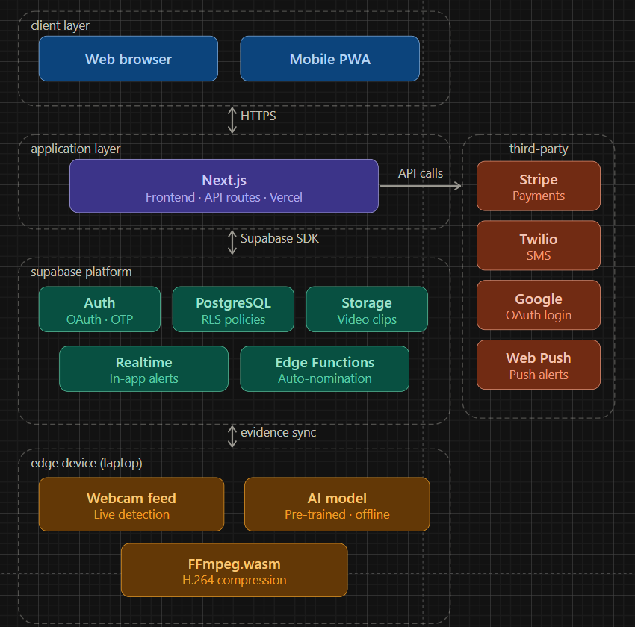
Figure 2 - High level system architecture diagram

System Architecture
The platform is structured across five distinct tiers as the figure above shows, each with a clearly defined responsibility. Together they form a cohesive system that handles user-facing interactions, business logic, data persistence, third-party integrations, and offline-capable AI field monitoring.
Tier 1 - Client Layer
The client layer is the entry point for all users interacting with the platform. It consists of two access modes that share the same underlying codebase and deliver an identical experience:
- Web Browser serves users accessing the platform through a standard desktop or laptop browser. This is the primary interface for HoD administrators managing training modules, reviewing certification applications, and accessing the evidence dashboard.

- Mobile PWA (Progressive Web App) allows guides and rangers to install the platform directly onto their mobile device home screen without requiring App Store or Play Store distribution. The PWA is built on top of the same Next.js frontend and is configured with a web app manifest and service worker that handles offline caching of both application assets and the AI detection model. On first load, the service worker fetches and caches the model file from the server, enabling the device camera and on-device inference to function fully without a network connection thereafter and push notification support via the Web Push API. This is the primary access mode for field staff who need reliable access in low-connectivity environments.
Both clients communicate exclusively with the application layer over HTTPS, ensuring all data in transit is encrypted.
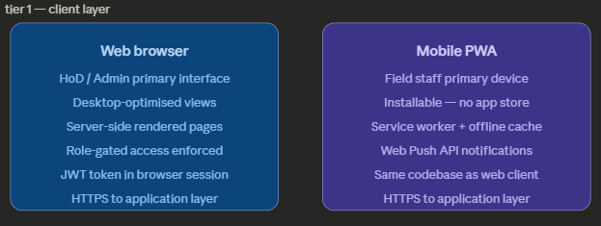
Figure 3 – Client Layer diagram
All requests originating from both client access modes are transmitted exclusively over HTTPS to the application tier, which serves as the sole gateway between the user-facing interface and all backend services — no client has direct access to the database, storage, or third-party APIs.

Tier 2 - Application Tier
The application layer is the central hub of the platform, built entirely on Next.js as a fullstack framework. It serves two responsibilities simultaneously:
- Frontend rendering — Next.js serves all UI pages for every role (Public, Guide, Ranger, Senior Guide, Senior Ranger, HoD, SFC Management). Role-specific views are enforced server-side, meaning users cannot access pages they are not authorised for regardless of client-side manipulation.

- API Routes — Next.js API routes handle all business logic including certification application processing, payment initiation via Stripe, notification dispatch via Twilio and Web Push, and communication with the Supabase platform. These routes run entirely server-side, keeping all credentials and sensitive operations away from the browser.
The application layer is deployed on Vercel, which provides automatic CI/CD on every push to the main branch, edge network distribution, and preview deployments for feature branches during development.
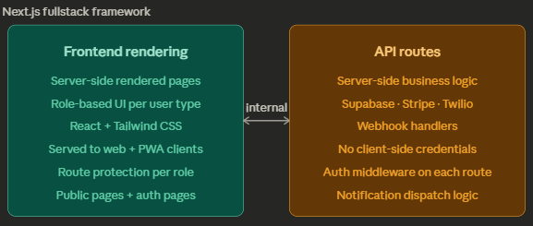
Figure 4 - Application Layer diagram
The application tier communicates with the Supabase platform via the Supabase SDK on the server side, delegating all data persistence, authentication state management, real-time event broadcasting, and background job execution to the

Tier 3 — Data Tier
Supabase serves as the unified backend infrastructure, consolidating five services under a single platform:
- Auth manages all user authentication. It supports two sign-in methods — Google OAuth for social login and OTP verification via email or phone number. Supabase Auth also issues and validates JWT tokens that carry the user's role, which all other Supabase services use to enforce access control.

- PostgreSQL is the primary relational database storing all structured data — user profiles, training records, certification applications, badge issuances, evidence metadata, and notification logs. Row Level Security (RLS) policies are defined at the database level, ensuring that each role can only read and write records they are authorised to access. For example, a guide can only query their own records, while a Senior Ranger can only see records belonging to their assigned group.

- Storage holds all binary assets uploaded to the platform, primarily the compressed H.264 evidence clips captured by the AI monitoring system. Each clip is stored with an access policy that restricts retrieval to authorised roles — guides cannot access other guides' clips, and senior staff can only access clips from their assigned group.

- Realtime powers the in-app notification channel. When a new notification record is inserted into the PostgreSQL database, Supabase Realtime broadcasts it instantly to the relevant user's active session over a WebSocket connection, delivering alerts without requiring the user to refresh the page.

- Edge Functions are serverless functions that run on Supabase's infrastructure, used for background tasks that should not block the main API. In this platform, Edge Functions handle the senior auto-nomination logic — periodically checking badge renewal history and promoting qualifying guides and rangers to Senior status automatically.
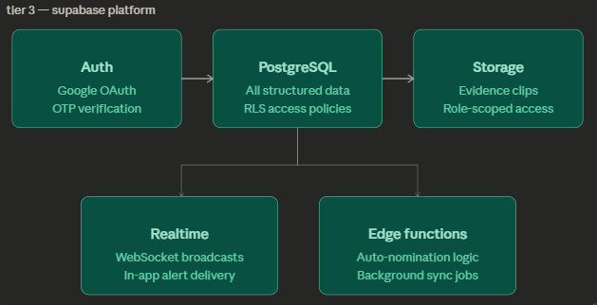
Figure 5 - Data Layer diagram
Where platform functionality requires capabilities beyond what Supabase provides natively — specifically payment processing, SMS delivery, and social authentication — the application tier makes outbound API calls to the following third-party service providers. All credentials for these services are held exclusively in server-side environment variables and are never exposed to the client.

Tier 4 — Third-Party Integrations
The application layer makes outbound API calls to four external service providers, each handling a specific function the platform does not implement natively:
- Stripe processes certification fee payments in sandbox mode. When a guide or ranger confirms enrolment in a certification programme, the application layer creates a Stripe payment session and redirects the user through Stripe's hosted checkout. On success, a webhook notifies the platform to proceed with enrolment confirmation.

- Twilio delivers SMS notifications for high-priority events where in-app or email alone is insufficient — such as interview scheduling, abnormal activity detection alerts, and certification outcomes. SMS is dispatched via a dedicated Next.js API route that constructs the message body based on the notification type before calling the Twilio REST API.

- Google OAuth is integrated through Supabase Auth to provide social login. When a user chooses to sign in with Google, Supabase manages the full OAuth 2.0 handshake, token exchange, and user profile creation without the platform needing to interact with Google's API directly.

- Web Push API enables push notifications to be delivered to PWA users even when the application is not open in the browser. The platform uses VAPID keys to authenticate push subscriptions, and notification payloads are sent server-side through the Web Push protocol when triggered by system events.
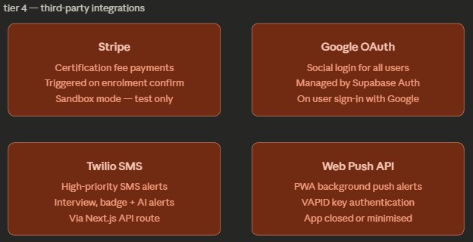
Figure 6 - Third-party Integration diagram
The edge device tier operates independently of all cloud infrastructure described above. While it communicates with the Supabase platform to upload evidence when connectivity permits, it is architecturally designed to function in full isolation — detection, compression, local storage, and on-device alerting all occur without any dependency on tiers 1 through 4 being reachable.

Tier 5 — AI Monitoring (On-Device Inference)
The AI monitoring tier is designed to function independently of network connectivity once the PWA has been initialised. It is not limited to a specific device — any PWA-capable device with a camera can serve as the monitoring endpoint. In the current prototype, a laptop or mobile device running the installed PWA serves this role.
- Model serving and caching — The pre-trained computer vision model is hosted on the server and registered as a service worker cache asset. When the PWA is first installed and opened, the service worker fetches the model file and stores it in the browser's cache storage alongside the application shell. On all subsequent sessions — including offline ones — the model loads directly from cache, with no server request required. This approach means the model is always available regardless of connectivity, and updates to the model can be pushed server-side and picked up automatically on the next online session.

- Device camera feed — Once a monitoring session is started, the device camera is initialised via the browser's MediaDevices.getUserMedia API. The live video stream is fed continuously into the cached model for frame-by-frame analysis.
- On-device inference — The model runs inference entirely within the browser using a WebAssembly-compatible ML runtime (such as TensorFlow.js). No video frames are transmitted to any server during analysis. This keeps inference latency low, preserves the privacy of recorded footage, and ensures the detection capability functions in areas with no network signal.

- Evidence pipeline — When a prohibited activity is detected above the confidence threshold, the system captures a timestamped clip, compresses it to H.264 using FFmpeg.wasm, then either uploads it immediately to Supabase Storage (if online) or queues it locally for background sync once connectivity is restored.

- On-device alert — An immediate sound and visual alert fires on the device at the moment of detection, independent of network status.
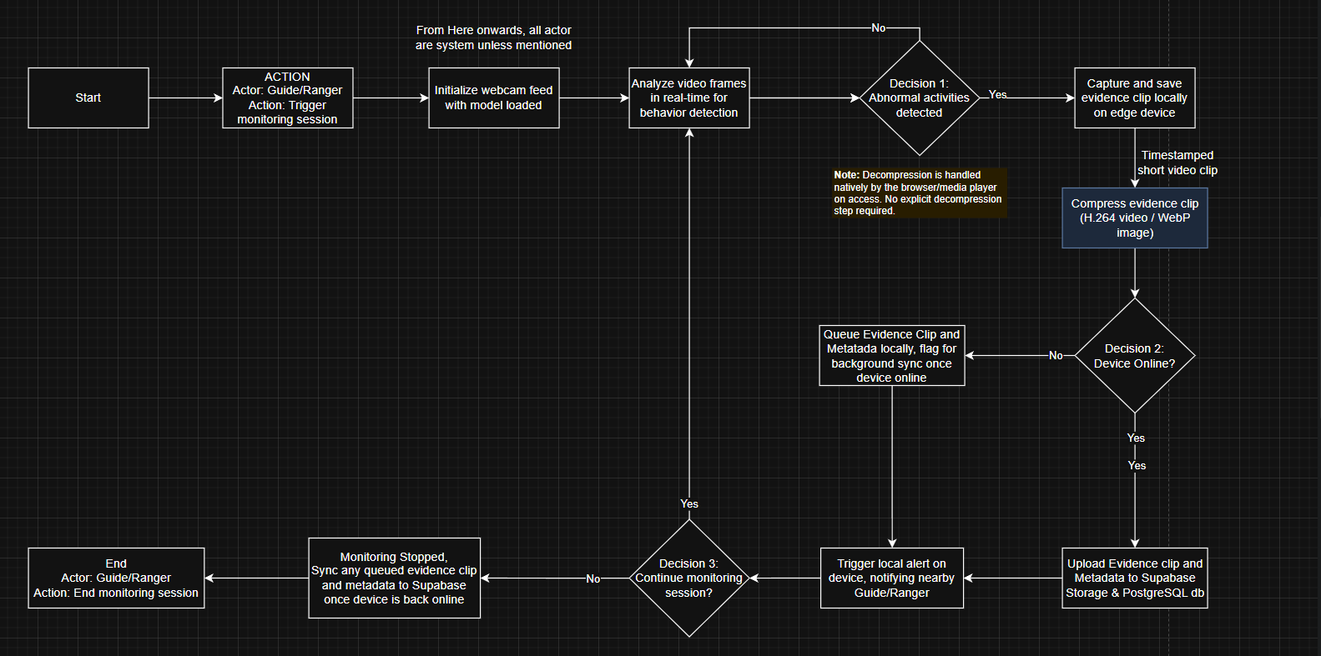
Figure 7 - AI Monitoring flow diagram

Executive Summary
The Sarawak Forestry Corporation (SFC) manages 67 Totally Protected Areas across Sarawak, supported by approximately 200–250 active licensed park guides and several hundred field rangers. Current training programmes are physically constrained and instructor-dependent, resulting in a guide workforce that remains below its target capacity and lacks consistent access to up-to-date conservation knowledge. Simultaneously, the absence of any real-time field monitoring mechanism leaves SFC's protected areas dependent on reactive rather than preventive enforcement.
This proposal describes the development of an integrated Digital Park Guide Training Platform — a custom-built web and mobile application that replaces the current training model with a flexible, self-paced e-learning system, while embedding an AI-powered monitoring capability that detects and records conservation violations during guided tours in real time.
The platform is built on Next.js and Supabase, deployed via Vercel, and designed to operate in the low-connectivity environments characteristic of Sarawak's remote parks. It will be delivered across two three-week sprints by a team of eight developers, producing a fully functional staging deployment, complete technical documentation, a security assessment, and user manuals for both field staff and administrators.

Quality Management
In the context of this project, quality is defined as the degree to which the delivered platform fulfils SFC's stated operational requirements reliably, securely, and accessibly — measured through functional correctness, security compliance, system performance, and user experience across all defined roles.
Quality is not measured by feature count alone. A platform that delivers all 22 backlog items but fails under concurrent users, exposes sensitive data through misconfigured access policies, or is too complex for a non-technical ranger to navigate independently does not meet the quality standard for this engagement. The following SMART quality criteria apply:
1. Functional Correctness
Specific: All 22 product backlog items must be implemented and demonstrable end-to-end without manual workarounds or hardcoded test bypasses.
Measurable: A structured test run covering every primary user flow (registration, training completion, certification application, badge issuance, AI detection, evidence upload) must pass with zero critical failures. A critical failure is defined as any failure that prevents a workflow from completing.
Achievable: Test cases will be written in Sprint 1 and executed in Sprint 2 prior to final deployment.
Relevant: SFC requires a platform that field staff and administrators can operate independently — any broken workflow directly undermines the platform's purpose.
Time-bound: All critical-path flows must pass testing by the end of Sprint 2, at least 3 days before the final submission deadline to allow time for fixes.

2. Security & Access Control
Specific: No user role must be able to access data, routes, or functionality outside their defined permission boundary, as specified by the role hierarchy in the Stakeholders section.
Measurable: Row Level Security (RLS) policies will be verified by attempting cross-role data access via both the application UI and direct Supabase API calls. Zero unauthorised data retrievals are acceptable — any policy bypass constitutes a security failure. The application vulnerability assessment must produce a reassessment report confirming all identified vulnerabilities have been remediated.
Achievable: RLS policies are defined at the database level in Supabase and are testable independently of the application code.
Relevant: The platform stores sensitive personal data, certification records, and video evidence — data leakage between roles would be a direct compliance and trust failure for SFC.
Time-bound: Initial RLS verification to be completed by the end of week 2 of Sprint 1. Vulnerability assessment and reassessment to be completed before the final week of Sprint 2.

3. AI Detection Reliability
Specific: The AI monitoring system must correctly detect defined prohibited activities and trigger the evidence capture pipeline without false-negative failures in a live demonstration environment.
Measurable: During acceptance testing, the system must successfully detect at least 3 distinct prohibited activity types with a confidence score at or above 70%, correctly capture and compress the evidence clip, and upload it to Supabase Storage within 60 seconds on a connected device. The offline queue must successfully sync at least one clip following simulated connectivity loss.
Achievable: Detection thresholds and compression parameters are configurable and will be tuned during Sprint 2 development.
Relevant: AI monitoring is one of the two core pillars of the platform — an unreliable detection system would undermine SFC's conservation enforcement objective entirely.
Time-bound: AI detection testing must be completed and documented by the end of Sprint 2 week 2, leaving a buffer for remediation before submission.

4. Performance & Accessibility
Specific: The platform must load within acceptable time thresholds and remain usable on standard mobile devices representative of those used by guides and rangers in the field.
Measurable: Initial page load on a 4G mobile connection must not exceed 5 seconds for the dashboard. The PWA must be installable and must serve cached content within 2 seconds when the device is offline. UI text and interactive elements must meet WCAG 2.1 Level AA contrast and sizing standards.
Achievable: Next.js server-side rendering and Vercel's edge network provide performance foundations. Lighthouse audits will be used as the measurement tool.
Relevant: Field staff in remote parks may be using older devices on degraded connections — a slow or inaccessible platform will simply not be used.
Time-bound: A Lighthouse audit must be run on the staging deployment by the final week of Sprint 2, with any scores below 70 (Performance, Accessibility) addressed before submission.

5. User Manual Completeness
Specific: Both user manuals (Guide/Ranger and HoD/Admin) must cover all primary workflows without requiring a reader to seek external assistance to complete a task.
Measurable: Each manual will be reviewed against a checklist of all primary workflows defined in the product backlog. Every workflow must be documented with step-by-step instructions and at least one supporting screenshot. Zero primary workflows may be undocumented.
Achievable: Manuals will be drafted in Sprint 2 once the UI is stable, using the working staging deployment for screenshots.
Relevant: The platform will be handed over to SFC for demonstration — administrators and guides must be able to operate the system independently without developer assistance.
Time-bound: Both manuals must be completed and reviewed internally by the end of Sprint 2 week 2.

Resources

Hardware
Resource | Purpose | Provider
Development laptops (×7) | Individual development workstations for each team member | Team-owned
Edge device with camera(×1) | Dedicated device for AI monitoring development, webcam testing, and FFmpeg.wasm compression benchmarking | Team-owned
Mobile devices (iOS and Android) | PWA installation and caching testing, mobile UI validation, push notification testing | Team-owned
Webcam | Live video feed input for AI monitoring session testing | Team-owned

Software & Services

Development Stack
Resource | Purpose | Licence / Tier
Next.js | Fullstack framework — frontend rendering and API routes | Open source (MIT)
React | UI component library (included with Next.js) | Open source (MIT)
Tailwind CSS | Utility-first CSS framework for UI styling | Open source (MIT)
Node.js | JavaScript runtime environment | Open source (MIT)

Backend & Infrastructure
Resource | Purpose | Licence / Tier
Supabase | Auth, PostgreSQL database, Storage, Realtime, Edge Functions | Free tier
Vercel | Hosting, CI/CD pipeline, preview deployments | Free tier
GitHub | Version control, branch management, pull request workflow | Free tier

Third-Party Integrations
Resource | Purpose | Licence / Tier
Stripe | Certification fee payment processing (sandbox mode) | Free (sandbox)
Twilio | SMS notification delivery | Free trial
Web Push API + VAPID keys | PWA push notification delivery | Browser-native (no cost)
Google OAuth (via Supabase Auth) | Social login authentication | Free (Google Cloud)

AI & Media Processing
Resource | Purpose | Licence / Tier
Pre-trained computer vision model (TBD — e.g. YOLOv8, MobileNet) | Abnormal activity detection — hosted on server, cached on-device via service worker | Open source (TBD)
TensorFlow.js / ONNX Runtime Web | In-browser WebAssembly ML runtime for on-device model inference | Open source  (Apache 2.0)
FFmpeg.wasm | In-browser H.264 video compression of evidence clips | Open source (LGPL)
MediaDevices API | Browser-native device camera feed capture | Browser-native  (no cost)

Development Tools
Resource | Purpose | Licence / Tier
Visual Studio Code | Primary code editor | Free
draw.io | System flow diagram creation | Free
Postman | API route testing and documentation | Free tier
npm | Package management | Free (open source)

Approval Signatures:
Project Team
Provide a summary of the team members and their roles.
 | Name of student | Student Id | Signature | Roles
1 | TERENCE CHIN SENG WONG | 104404059 | WONG | Project Lead, Full Stack Lead, AI & Media Engineer
2 | TAMMY RU XIU TAY | 104405861 | TAY | Full Stack Developer, AI & Media Engineer
3 | MIAW FONG LIM | 104406013 | LIM | Frontend Developer
4 | EMILY HUI XIU JONG | 102788832 | JONG | Frontend Developer
5 | ZI YANG LIM | 102774129 | LIM | Full Stack Developer, AI & Media Engineer
6 | YOUNG FUNG LAU | 102774585 | LAU | Backend Developer, QA & Security Engineer
7 | BRIAN JIA HUA LIEW | 104381288 | LIAW | Backend Developer, QA & Security Engineer

Project Sponsor [Dr. Lee Su Han]
Tutor’s name (on behalf of the client) | Signature:

This document is by no means a “full project proposal”. It has been simplified and customized for the purposes of MSP teaching. The full project proposal includes many other sections which have not been discussed during the first few weeks of MSP teaching.

